Waleed Mostafa

MVP - Cloud and Datacenter Management
Senior Consultant

August 2017

AnyWhere365 MP Guide
Version 1.0
Table of contents
1 Introduction 2
2 Guide History 3
3 Supported Configurations 4
4 Files in this Monitoring Pack 5
5 Diagram 6

Introduction
This guide was written based on Initial version of SCOM Management pack 1.0.0.8 of the Monitoring Pack Anywhere365.

Guide History
Release Date | Changes
August 2017 | Original release of this guide

Supported Configurations
- System Center Operations Manager 2007 R2 (64-bit)
  - Microsoft SQL Server® 2008 R2 database software
- System Center Operations Manager 2012 (64-bit)
- System Center Operations Manager 2012 R2 (64-bit)
- System Center Operations Manager 2016 (64-bit)

Files in this Monitoring Pack
The Monitoring Pack for Anywhere365 includes the following files:
- WSPWM.Anywhere365.mp

Diagram

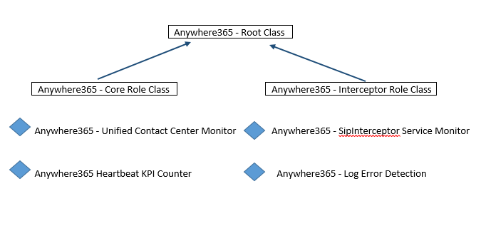
Monitors
Anywhere365 - Unified Contact Center Monitor
Anywhere365 Heartbeat KPI Counter
Anywhere365 - SipInterceptor Service Monitor

Rules
Anywhere365 - Log Error Detection

